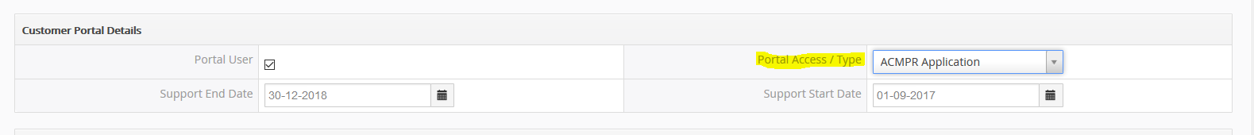

Module = Contact

Block = Customer Portal Details

Picklist = Portal Access / Type

**Function Needed:** Choosing different options will auto populate / give them access to specific templates built into the customer web portal.

**Priority #1 = Build out the following template in customer web portal for ACMPR Application**

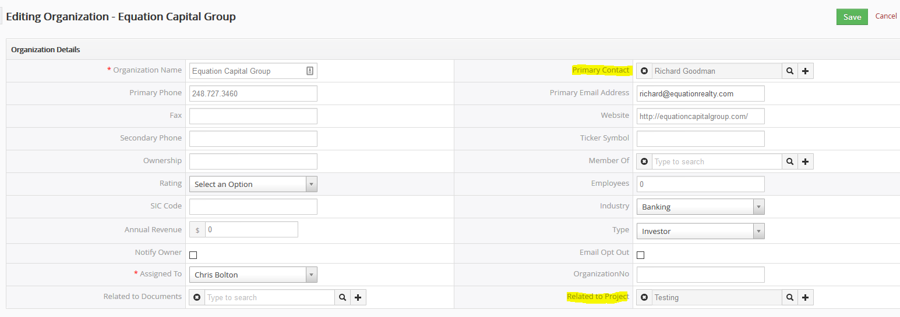

* Added “Related to Project” filed under Organization Module

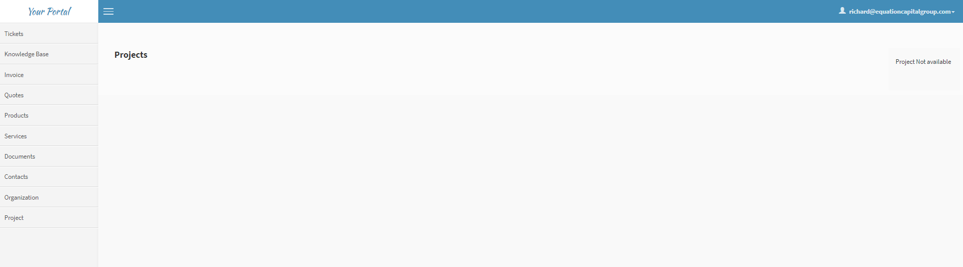

* Needs to automatically populate in Customer Portal



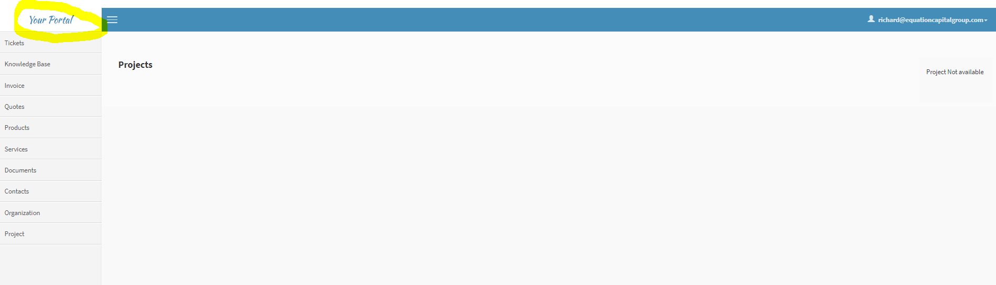

* Please have the above logo displayed in upper left corner for everyone logging in

**Need the Following Modules & Functionalities to appear:**

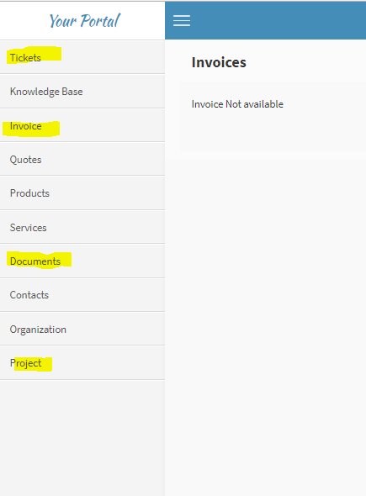

* Tickets = Needs to display all tickets associated with Contact & Organization:

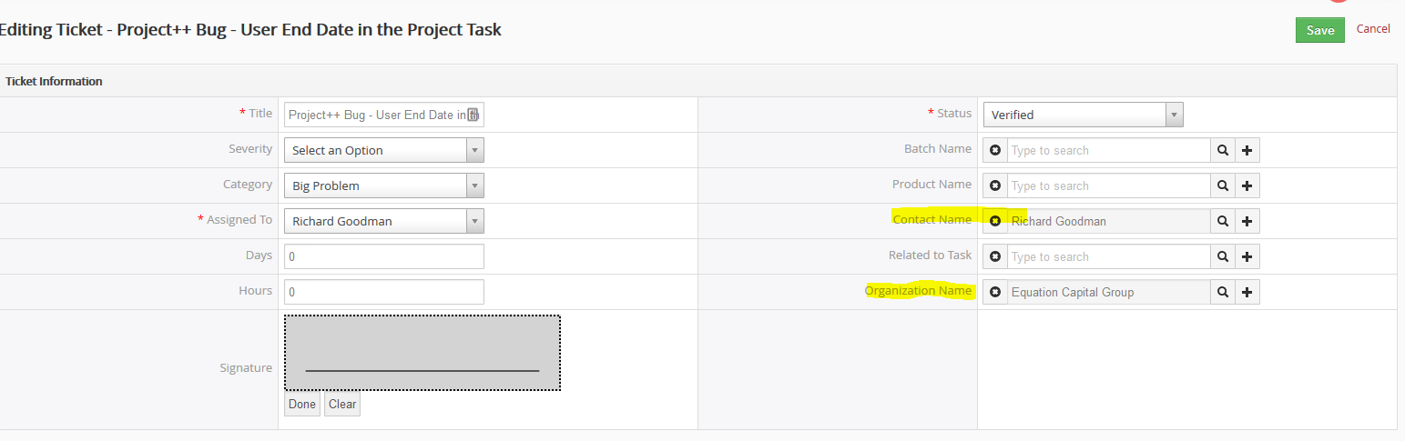

* Invoice = Needs to display all invoices associated with Contact & Organization:

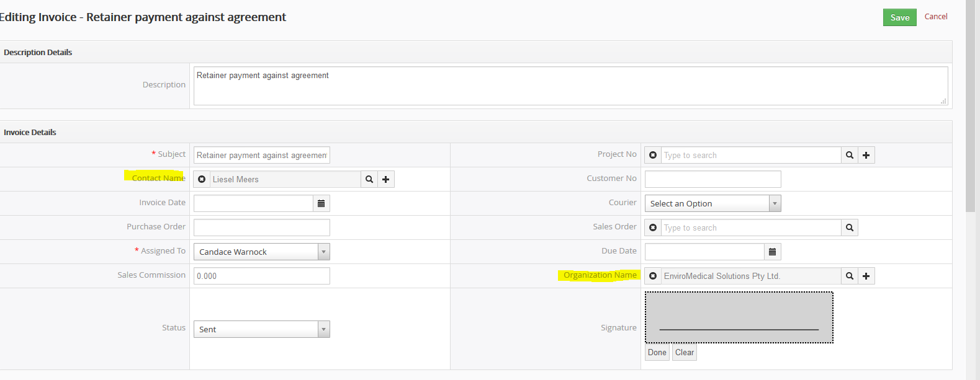

* Documents =

For this we will need a “template” page that allows for a variety of documents to be uploaded by the client. We will provide you with a complete list but if you look under edit in the Organization module you will see examples under the corresponding blocks:

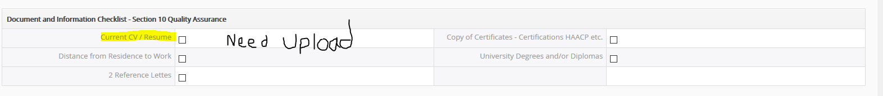

* When a document is uploaded, notification needs to be sent to the assigned project “manager”.
* The manager needs to review said document (just like change order function)
* Once approve it will then show up in the portal as Complete (little green check mark?)
* We will also need the ability to send out automatic emails to organization / client stating which documents are still missing / need to be uploaded.
* A widget show % completed – ACMPR document upload

We need a **chat feature** in here for client / organization communications.

We need the **Change Order** module in here.